WHITE PRAWN MODEL

Abstract:
This report outlines the development and refinement of White prawn models for classifying the freshness of prawns as either "bad" or "good." Over four iterations (V1 to V4), the models have undergone enhancements in various aspects to improve accuracy and reliability. This report presents a detailed analysis of each version, including the challenges encountered, solutions implemented, and the corresponding accuracies achieved.

High-Level Tech Stack:
Common Image processing libraries, Frameworks and Development platforms used (These are common for all the 4 versions of White prawns):
- Deep Learning Framework: Tensorflow with Keras, Pytorch
- Programming: Python
- Image processing libraries: OpenCV, Pillow, Ultralytics, Scikit-Image
- Data visualization and Plotting: Matplotlib, Seaborn
- Development platform: Jupyter notebook

Dataset Analysis:
- Size: Initial the overall dataset size was 4775 belong to both classes ‘Bad’ and ‘Good’.
- Problems: There were two major problems.
  - First, there were so many misclassified images, which consist of images of Sea prawn, Red prawn and Tiger prawns.
  - And then while segmentation, since most of the images were grouped images, and their shapes were not as simple as compared to the fishes, we were not getting the best segmented images.

Metrics used for Model Evaluation:
- Confusion Matrix:
  - The matrix contains information about true positive (TP), true negative (TN), false positive (FP), and false negative (FN) predictions made by the model.
  - TP: Actual positive cases correctly predicted as positive.
  - TN: Actual negative cases correctly predicted as negative.
  - FP: Actual negative cases incorrectly predicted as positive (Type I error).
  - FN: Actual positive cases incorrectly predicted as negative (Type II error).
  - The values in the confusion matrix can be used to calculate various evaluation metrics such as accuracy, precision, recall, and F1-score.

- F1-Score:
  - The F1-score is a metric commonly used for evaluating the performance of classification models, particularly when dealing with imbalanced datasets.
  - It is the harmonic mean of precision and recall, providing a single score that balances both metrics.
  - Precision measures the accuracy of positive predictions, while recall measures the ability of the model to capture positive instances.
  - The F1-score reaches its best value at 1 and worst value at 0. A higher F1-score indicates better model performance in terms of both precision and recall.
  - It is calculated using the formula:
f1 = 2 * (precision * recall) / (precision + recall)

Model Development Overview:

- WHITE PRAWN-V1: (07-Dec-23 to 26-Dec-23)
In this model version, we have intentionally kept the other three species of prawns, since they were less in number and we were expecting to create a common model for all prawns.
And, in this version we had to use those grouped images which resulted in improper image segmentation.
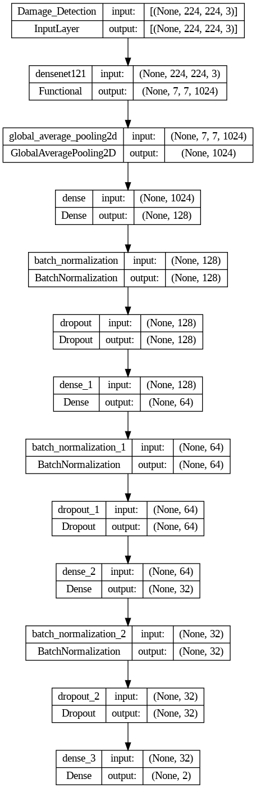
- MODEL ARCHITECTURE: The V1 architecture is as follows.

- Model parameters:
  - Base – DenseNet121 (Transfer Learning)
  - Batch size – 32
  - Dropout – [0.4, 0.3, 0.2]
  - L2 regularize – 0.005
  - Output Activation function – Softmax
  - Metric – Custom F1 score and F1 for class ‘Good’
  - Loss – Custom F1 loss (Combination of Categorical cross entropy and negative f1 score)
  - Call-backs – Learning rate schedule, Early stopping
  - Learning rate – 1e-3
  - Optimizer - Adam

- Dataset size:
  - Data augmentation - Done
  - Train – 2865
  - Validation – 955
  - Test – 955
  - Unseen test – 609

- Image pre-processing:
  - Most of the images collected during this period were grouped images. Since they were overlapping on each other, it was not feasible to use the cropped images.
  - So, from the first iteration we started to use the segmented images with black background.
  - We resized them to (224, 224) without preserving the aspect ratio.
  - Then we normalized the image pixel values to lie in between 0 and 1.
  - This was the pre-processing step for the version 1.

- Validation of Version V1:
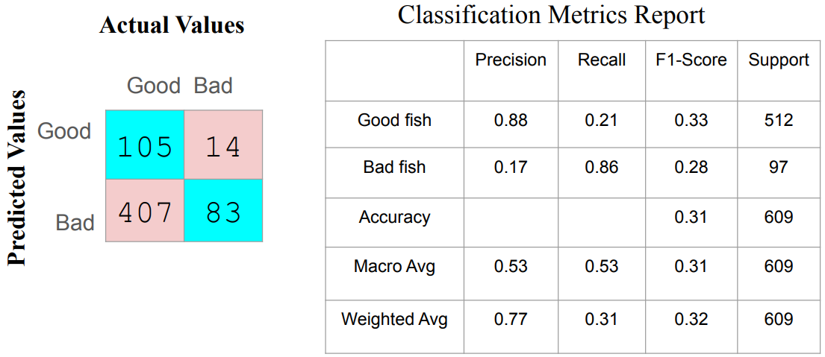

- Problems with Version V1:
  - The overall accuracy of the model was low. It had good precision for class ‘Good’ and good recall value for class ‘Bad’.
  - The overall accuracy was only 31% which was significantly lower.
  - This low performance was effectively due to two reasons. Firstly, the segmentation model was not extracting the prawns properly from grouped / overlapped prawns. Secondly, including the different prawn’s species.

- WHITE PRAWN-V2: (27-Dec-23 to 31-Dec-23) & (10-Jan-24 to 22-Jan-24)
In this version of the model we decided to use only the images of single prawns (and well separated prawns). And we also removed the other species prawns from the dataset.
In terms on number of layers and neurons and dropout layers it is exactly like version V1. But, in this version we have used the binary encoding for labels and used sigmoid output activation function.

- MODEL ARCHITECTURE: The V2 architecture is as follows.
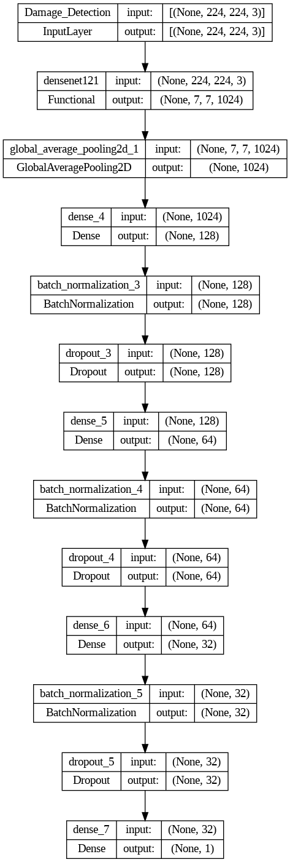

- Model parameters:
  - Base – DenseNet121 (Fine tuning, frozen 4 out of 5 blocks)
  - Batch size – 32
  - Dropout – [0.4, 0.3, 0.2]
  - L2 regularize – 0.005
  - Output Activation function – Sigmoid
  - Metric – F1 score
  - Loss – Binary cross entropy
  - Call-backs – Learning rate schedule, Early stopping
  - Learning rate – 1e-5
  - Optimizer – Adam

- Dataset size:
  - Data augmentation - Done
  - Train – 2325
  - Validation – 775
  - Test – 775
  - Unseen test – 733

- Image pre-processing:
  - Segmented and resized to (224, 224) without preserving the aspect ratio.
  - Then processed through Densenet’s input pre-processing function.

- Validation of Version V2:

- Evaluated for two iterations:
- (27-Dec-23 to 31-Dec-23)
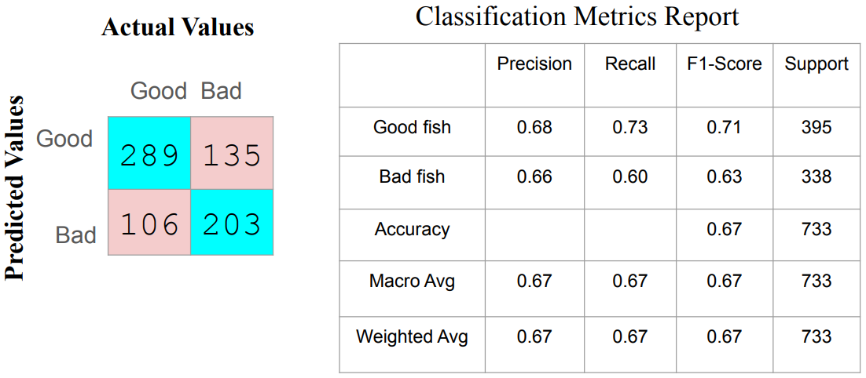

- The model achieved overall accuracy of 67%.
- The improvement happened after removing the other species of prawns and training it on single prawn images.

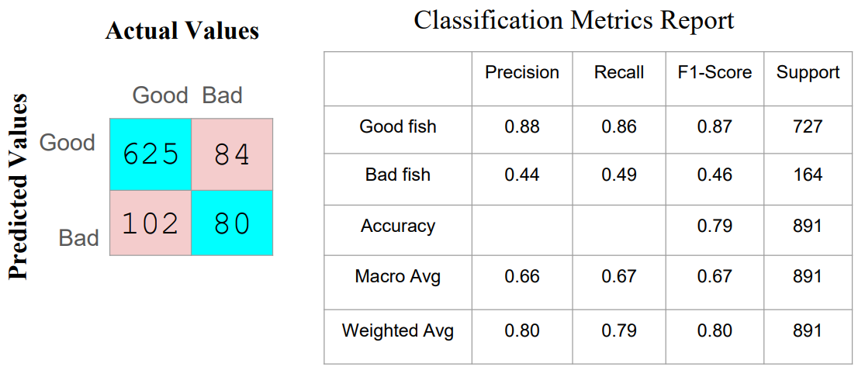
- (10-Jan-24 to 22-Jan-24)

- The same model was again continued after V3. And it achieved overall 79% during this period of testing.
- It was performing well for ‘Good’ class but not so well for ‘Bad’ class.

- Problems with Version V2:
  - The overall accuracy for ‘Good’ class was still lower than expectations during 1st iteration. But it was improved in 2nd iteration of testing.
  - But for ‘Bad’ class in both iterations it was lower especially during 2nd iteration.

- WHITE PRAWN-V4: (10-Jan-24 to 14-Mar-24)
This version has architecture like the version V2, the only difference was in the size of dataset and fine tuning more layers.
For this model in fine tuning, we frozen only first 3 blocks out of the 5 blocks in DenseNet121.

- Model parameters:
  - Base – DenseNet121 (Fine tuning, frozen 3 out of 5 blocks)
  - Batch size – 32
  - Dropout – [0.4, 0.3, 0.2]
  - L2 regularize – 0.005
  - Output Activation function – Sigmoid
  - Metric – F1 score
  - Loss – Binary cross entropy
  - Call-backs – Learning rate schedule, Early stopping
  - Learning rate – 1e-5
  - Optimizer – Adam

- Dataset size:
  - Data augmentation - Done
  - Train – 7495
  - Validation – 1548
  - Test – 1542
  - Unseen test – 657

- Validation of Version V4:
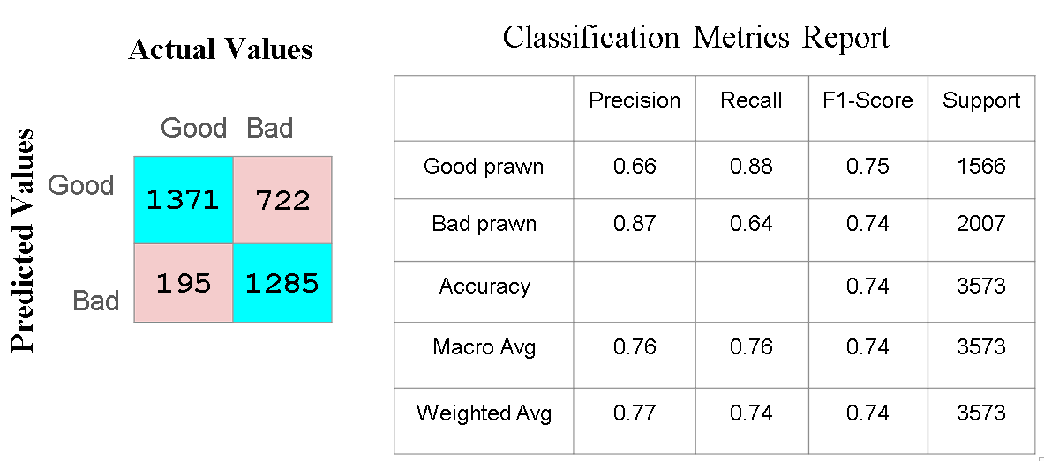

  - The overall accuracy was 74%
  - The recall and precision for ‘Bad’ improved compared to all the previous versions

- Problems with Version V4:
  - The recall rate for ‘Bad’ class is 64%, which is lower than expected value.
  - Same goes for the precision of ‘Good’ class.

- WHITE PRAWN-V5: (25-Mar-24 to Present)
This is the latest version, it has different model architecture as shown in the below diagram since it was designed with keras tuner to find hyper parameters, one more difference was in the size of dataset.
And the fine-tuning process is same as for previous version.

- Model parameters:
  - Base – DenseNet121 (Fine tuning, frozen 3 out of 5 blocks)
  - Batch size – 32
  - Dense – [128, 2048, 512, 64]
  - Dropout – [0, 0, 0.2, 0.1]
  - L2 regularize – 0.005
  - Output Activation function – Sigmoid
  - Metric – F1 score
  - Loss – Binary cross entropy
  - Call-backs – Learning rate schedule, Early stopping
  - Learning rate – 1e-5
  - Optimizer – Adam

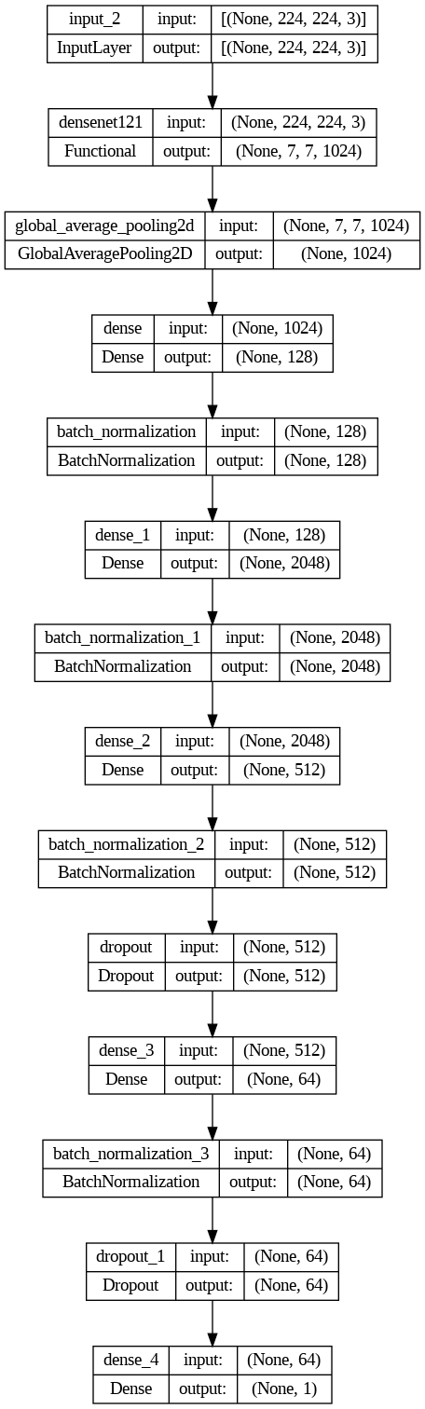
- MODEL ARCHITECTURE: The V5 architecture is as follows.

- Dataset size:
  - Data augmentation - Done
  - Train – 10792
  - Validation – 2388
  - Test – 2401

- Validation of Version V5:
  - As of 19th March 2024, there has been no testing done from the latest White prawn’s model version

- WHITE PRAWN-V6: (14-March to 17-April-24)
This model also has the same model architecture as V5 version only the dataset was updated.

- Dataset size:
  - Data augmentation - Done
  - Train – 12617
  - Validation – 2616
  - Test – 2629
  - Unseen – 1039

- Validation of Version V6:
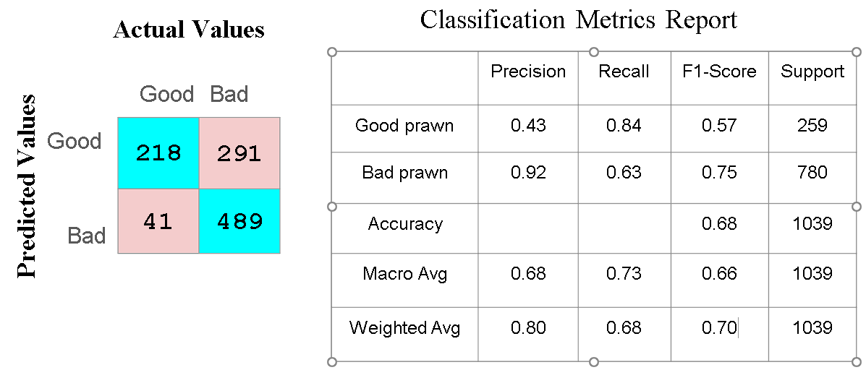

- WHITE PRAWN-V7 and V8: (17-April-24 to 08-Sep-24)
The segmentation model used to detect and extract the white prawns was enhanced in these versions to be more robust, ensuring that it does not mistakenly detect the fish as prawns.

- WHITE PRAWN-V9: (09-Sept-24 to 30-Dec-2024)
In this version, the model was retrained using the updated dataset while maintaining the same model architecture.

- Dataset size:
  - Data augmentation - Done
  - Train – 14627
  - Validation – 2866
  - Test – 2861
  - Unseen – 423

- Validation of Version V9:
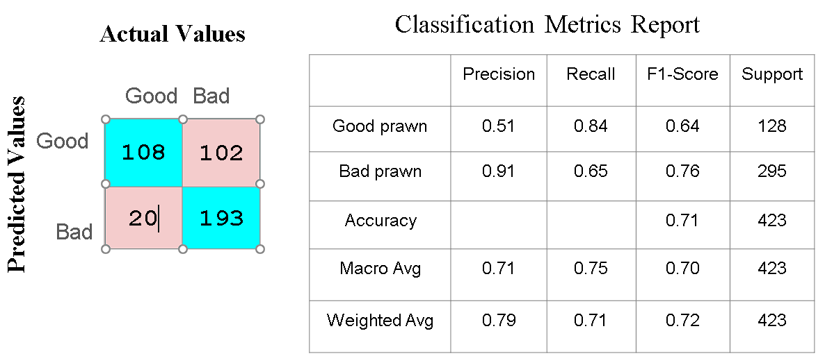

- WHITE PRAWN-V10: (30-Dec-2024 to present)
This is the latest white prawn model with updated dataset of the following size and has the same model architecture. (Along with the Image compression)

- Dataset size:
  - Data augmentation - Done
  - Train – 17726
  - Validation – 3111
  - Test – 3086
  - Unseen – 15

- Validation of Version V10 (Unseen):
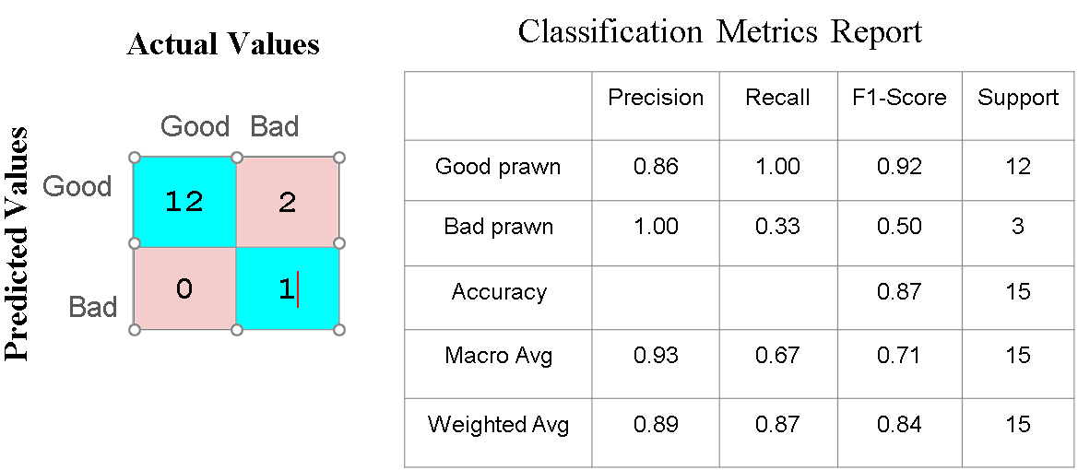

- Validation of Version V10 (Test):
